

*Journal of Geophysical Research: Solid Earth*

Supporting Information for

***P–T–t* path of garnetites in South Altyn Tagh, West China: a complete record of the ultradeep subduction and exhumation of continental crust**

Jie Dong1, Chunjing Wei1, Jing Chen2 & Jianxin Zhang3

1MOE Key Laboratory of Orogenic Belts and Crustal Evolution, School of Earth and Space Sciences, Peking University, Beijing 100871, China

2Electron Microscopy Laboratory, School of Physics, Peking University, Beijing 100871, China

3Institute of Geology, Chinese Academy of Geological Sciences, Beijing 100037, China

**Contents of this file**

Text S1

Figures S1 to S4

Tables S1 to S4

**Introduction**

This supporting information provides: detailed analytical methods on bulk-rock composition measurements, mineral chemistry measurements, exsolution texture observation and Zircon U–Pb dating (shown in Text S1); Supporting Figures S1 to S4; Selected microprobe analyses of garnet, clinopyroxene, plagioclase, amphibole and perthite for sample A1505 from the Bashiwake area (Table S1); Normalized molar proportion used for phase equilibria modelling (mol. %) for sample A1505 (Table S2); LA-ICP-MS U-Pb results for separated zircons from the garnetite sample A1505 (Table S3); In situ SIMS U-Pb results for zircons in thin sections from the garnetite sample A1505 and zircon standard Qinghu (Table S4).

Text S1. Analytical methods

**1. Bulk-rock composition measurements**

The bulk-rock composition of sample A1505 was determined using a Leeman Prodigy inductively coupled plasma-optical emission spectroscopy (ICP-OES) system with high-dispersion Echelle optics at the China University of Geoscience (Beijing). The GSR-1, GSR-3, GSR-5 (National geological standard reference materials of China), and USGS (US Geological Survey) AGV-2 samples were used as standards. The analytical precision (1σ) for most major elements is better than 1%, except for TiO2 (~1.5%) and P2O5 (~2.0%). Loss on ignition was determined by placing 1 g of sample powder in a furnace at 1000 °C for several hours and reweighed in a desiccator (Song et al., 2018).

**2. Mineral chemistry measurements**

Major element compositions of minerals in thin sections were analyzed using a JEOL JXA-8230 electron microprobe at Peking University. Detailed information about the electron microprobe is described in Li et al. (2018). Operation conditions involved a 15 kV acceleration voltage, a 10 nA beam current, a counting time of 10–15 s and a beam diameter of 1–2 μm for all analyses except for exsolution lamellae within garnet, clinopyroxene and perthite (with focused beam spot). 53 kinds of natural and synthetic minerals from the SPI Company were used for standardization: sanidine was employed for K; rutile for Ti; chromium oxide for Cr; diopside for Ca and Mg; jadeite for Na, Al and Si; rhodonite for Mn and hematite for Fe. Representative mineral compositions are listed in Table S1. The rehomogenized compositions of perthite and garnet were calculated from the volume proportions of the exsolved lamellae estimated by image analysis program ImageJ ver. 1.6, based on backscattered electron (BSE) images and optical imagery (Fig. 3), combined with the densities of the two feldspars (2.67 and 2.57 g/cm3 for plagioclase and alkali feldspar from Smith (1974)); rutile/ilmenite and garnet (4.23 g/cm3 for rutile, 4.72 g/cm3 for ilmenite and average value of 3.90 g/cm3 for garnet from Anthony et al. (2011)).

**3. Exsolution texture observation**

The microstructures and the topotaxial relationship between the exsolved pigeonite lamellae and the host clinopyroxene are identified with a Hitachi F30 high-resolution transmission electron microscope (TEM) operating at 300 kV accelerating voltage in the Electron Microscopy Laboratory, School of Physics, Peking University. The TEM is equipped with an energy-dispersive X-ray spectrometer with an ultra-thin-window detector, enabling the identification of elements ranging from B to U. Electron-transparent foils were prepared by ion-beam thinning from petrographic thin sections using a Gatan 600 DuoMill.

**4. Zircon U–Pb dating**

In order to constrain the timing of metamorphism, zircon grains within thin sections were chosen for in situ SIMS U–Pb dating and separated zircons were also selected for LA-ICP-MS U–Pb dating and trace element measurements. Zircons grains within thin sections were sampled through drilling procedures and zircon grains in the hand specimen were separated by standard heavy liquid and magnetic separation followed by hand-picking under a binocular microscope. Drilled slices of thin sections and separated grains were mounted in two epoxy resins respectively, polished down to expose the zircon grain centers, photographed in transmitted and reflected light, and imaged using cathodoluminescence (CL).

U–Th–Pb isotopic ratios and trace element concentrations on separated zircons were measured at Peking University using an Agilent 7500c ICP-MS system connected with a 193 nm ArF Excimer laser system (COMPexPro 102) with automatic positioning system. The spot diameter is about 30 μm. Zircon 91500 was used as a standard and the standard silicate glass NIST used to calibrate the instrument. Elemental concentrations of U, Th and Pb were calibrated using 29Si as an internal calibrant and NIST 610 as an external reference standard. 207Pb/206Pb, 206Pb/238U and 207Pb/235U ratios and apparent ages were calculated using GLITTER 4.4 (Van Achterbergh et al., 2001). The data and results are listed in Table S3.

In situ measurements of U, Th and Pb isotopes of zircons in thin sections were performed using a Cameca IMS 1280 large-radius SIMS at the Institute of Geology and Geophysics, Chinese Academy of Sciences in Beijing. Detailed analytical procedures are the same as those described by Li et al. (2010). The ellipsoidal spot is about 10×15 μm in size. Zircon standards Plešovice and 91500 were used to calibrate Pb/U ratios, U and Th concentrations respectively. Measured compositions were corrected for common Pb by nonradiogenic 204Pb. An average of present-day crustal composition (Stacey and Kramers, 1975) was adopted for common Pb, assuming that the common Pb is largely related to surface contamination introduced during sample preparations. The Isoplot/Ex v.3.75 software (Ludwig, 2012) was used for data reduction. Uncertainties in individual analyses are reported at the 1δ level. The “207-corrected” ages were calculated by projecting the uncorrected analysis onto concordia from the assumed common 207Pb/206Pb composition. Zircon standard Qinghu was alternately analyzed as an unknown with other sample zircons to monitor the external uncertainties of SIMS U–Pb dating. Six measurements conducted on Qinghu zircons yielded a concordia age of 159.4 ± 1.8 Ma, which is identical to the recommended value of 159.5 ± 0.2 Ma within error (Li et al., 2013). The U–Pb data and results are listed in Table S4.

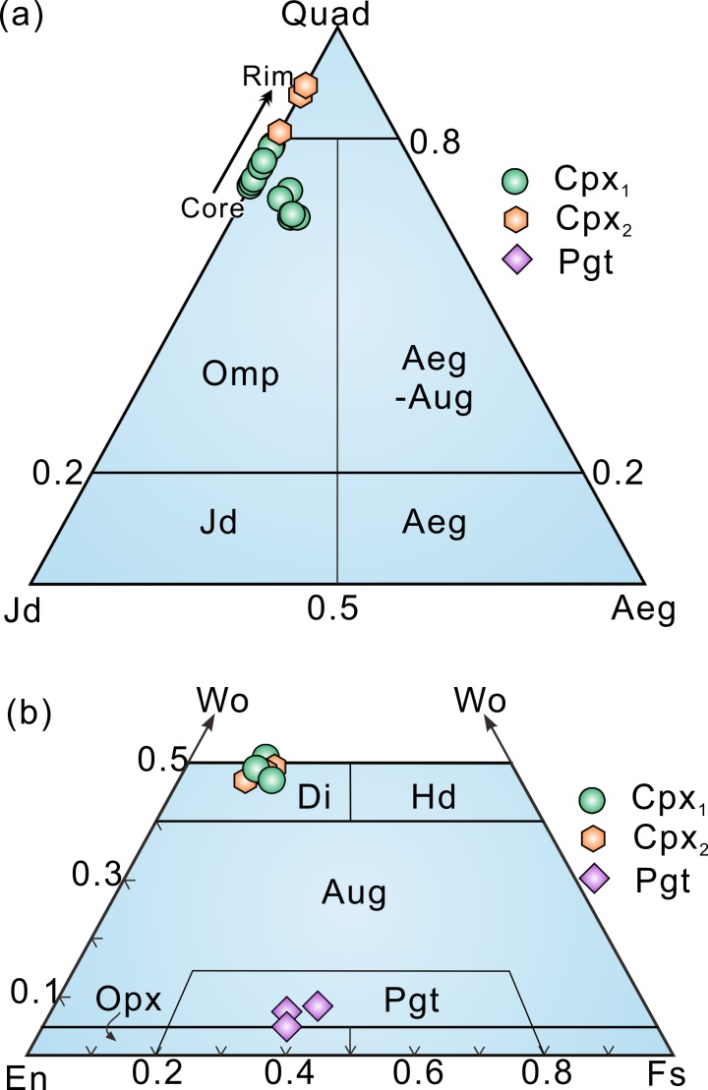

Figure S1. Mineral compositional diagrams of clinopyroxene for sample A1505. Wo = Ca2+/(Fe2+ + Mg + Ca); En = Mg2+/(Fe2+ + Mg + Ca); Fs = Fe2+/(Fe2+ + Mg + Ca)]; Jd= (2Na / (2Na + Ca + Mg + Fe2+)) · (Al /(Al + Fe3+). Classifications are after Morimoto (1988). Representative compositions of core and rim in Cpx and Pgt are shown in Table S1.

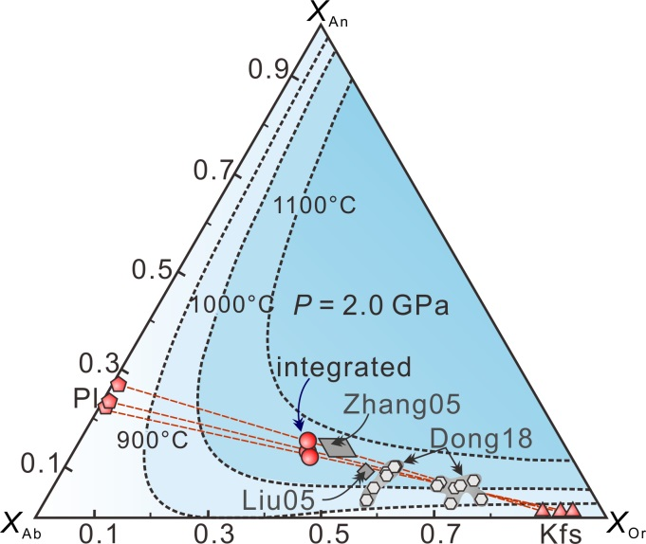

Figure S2. Compositions of the rehomogenized ternary feldspar from sample A1505 (Table S1) and other ternary feldspar compositions from neighboring mafic granulites and felsic granulites in the Bashiwake area. Labels Zhang05 and Liu05 refer to the data of mafic granulites from Zhang et al. (2005) and Liu et al. (2005). Label Dong18 refers to the data of felsic granulites from Dong et al. (2018). Solvus isotherms at *P* = 2.0 GPa were adapted from Nahodilová et al. (2011).

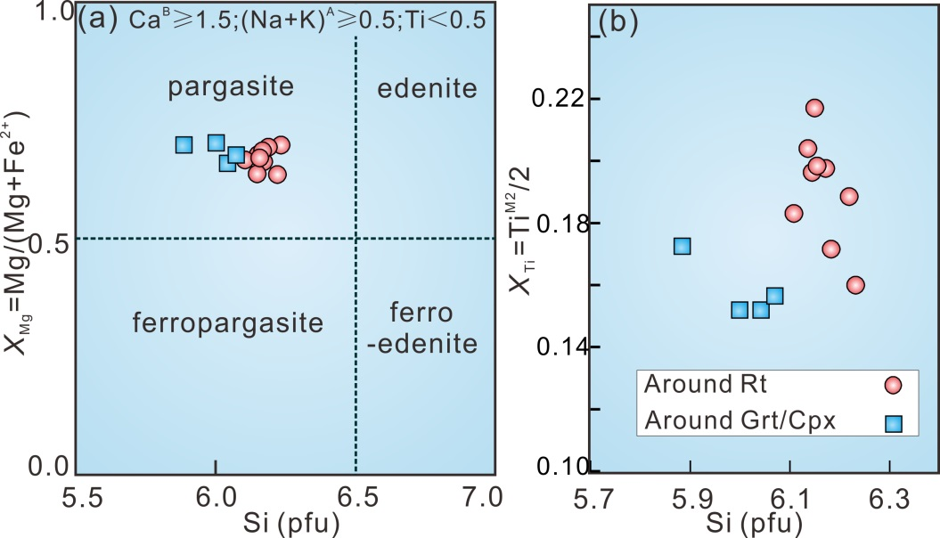

Figure S3. Mineral compositional diagrams of amphibole (a & b) around rutile and garnet/clinopyroxene for samples A1505. Classification in (a) is after Leake et al. (1997).

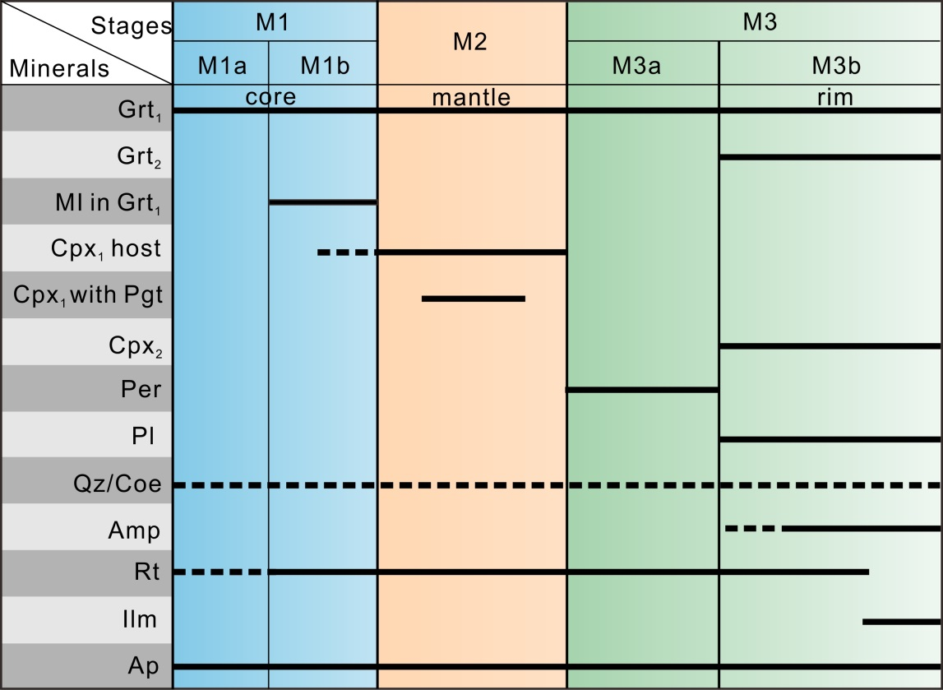

Figure S4. A summary of the generations of mineral assemblages for the studied garnetite sample A1505 based on petrography and mineral compositions. The solid lines show the presence of minerals in the sample, and the dashed lines indicate the possible presence of a mineral.

|  |  |  |  |  |  |  |  |  |  |  |  |  |  |  |  |  |  |  |  |  |  |  |  |
| --- | --- | --- | --- | --- | --- | --- | --- | --- | --- | --- | --- | --- | --- | --- | --- | --- | --- | --- | --- | --- | --- | --- | --- |
| **Table S1**. Selected microprobe analyses of garnet, clinopyroxene, plagioclase, amphibole and perthite for sample A1505 from Bashiwake area. | | | | | | | | | | | | | | | | | | | | | | | |
| Minerals | Grt1 | | |  | Grt2 | |  | Cpx1 | | Cpx2 | | Pgt |  | Plagioclase | | |  | Amphibole | |  | Perthite | | |
| Grt-A | Grt-B | Grt-C |  | Grt-A | Grt-B |  | Cpx-C | Cpx-R | Cpx-C | Cpx-R |  | in Matrix | | in Cpx |  | Amp1 | Amp2 |  | Kfs | Pl | integrated |
| SiO2 | 39.18 | 39.31 | 39.75 |  | 38.98 | 38.53 |  | 53.60 | 50.15 | 50.10 | 50.83 | 49.82 |  | 61.03 | 58.05 | 62.69 |  | 42.24 | 40.02 |  | 64.34 | 60.56 | 62.30 |
| TiO2 | 0.18 | 0.14 | 0.11 |  | 0.25 | 0.15 |  | 0.28 | 1.27 | 1.13 | 0.93 | 0.11 |  | 0.05 | 0.27 | - |  | 3.96 | 3.12 |  | - | 0.02 | 0.02 |
| Al2O3 | 22.06 | 22.87 | 22.99 |  | 21.43 | 21.21 |  | 7.14 | 8.52 | 8.67 | 5.26 | 5.57 |  | 25.00 | 26.72 | 24.31 |  | 14.59 | 15.72 |  | 18.99 | 25.25 | 22.36 |
| Cr2O3 | - | 0.04 | - |  | - | 0.04 |  | - | 0.02 | 0.02 | 0.08 | - |  | - | 0.04 | 0.02 |  | - | 1.39 |  | - | - | - |
| FeO | 21.64 | 21.35 | 21.24 |  | 22.13 | 23.88 |  | 8.06 | 8.22 | 8.63 | 8.68 | 22.12 |  | 0.21 | 0.11 | 0.36 |  | 10.80 | 12.15 |  | 0.05 | 0.07 | 0.06 |
| MnO | 0.44 | 0.34 | 0.43 |  | 0.47 | 0.64 |  | 0.06 | 0.07 | 0.04 | 0.06 | 0.19 |  | 0.02 | - | 0.05 |  | 0.04 | 0.02 |  | - | 0.03 | 0.02 |
| MgO | 6.42 | 8.97 | 9.42 |  | 8.79 | 8.26 |  | 10.03 | 10.46 | 10.83 | 11.76 | 18.43 |  | - | - | - |  | 12.00 | 11.43 |  | - | - | - |
| CaO | 10.26 | 7.42 | 7.04 |  | 7.23 | 6.49 |  | 16.69 | 18.78 | 18.42 | 20.34 | 3.45 |  | 5.60 | 7.57 | 4.82 |  | 10.90 | 10.20 |  | 0.09 | 5.84 | 3.19 |
| Na2O | - | - | - |  | - | 0.03 |  | 4.04 | 2.49 | 2.35 | 1.63 | 0.10 |  | 8.32 | 7.02 | 8.56 |  | 2.70 | 2.70 |  | 1.16 | 8.61 | 5.17 |
| K2O | - | - | - |  | - | - |  | - | - | - | - | - |  | 0.06 | 0.01 | 0.03 |  | 0.42 | 0.22 |  | 15.27 | 0.12 | 7.11 |
| Totals | 100.18 | 100.44 | 100.98 |  | 99.28 | 99.23 |  | 99.90 | 99.98 | 100.19 | 99.57 | 99.92 |  | 100.29 | 99.79 | 100.84 |  | 97.65 | 96.97 |  | 99.90 | 100.50 | 100.22 |
| O | 12 | 12 | 12 |  | 12 | 12 |  | 6 | 6 | 6 | 6 | 6 |  | 8 | 8 | 8 |  | 23 | 23 |  | 8 | 8 | 8 |
| Si | 3.00 | 2.98 | 2.98 |  | 2.99 | 2.98 |  | 1.95 | 1.85 | 1.84 | 1.89 | 1.87 |  | 2.70 | 2.60 | 2.75 |  | 6.15 | 5.88 |  | 2.97 | 2.68 | 2.81 |
| Ti | 0.01 | 0.01 | 0.01 |  | 0.01 | 0.01 |  | 0.01 | 0.04 | 0.03 | 0.03 | 0.00 |  | 0.00 | 0.01 | - |  | 0.43 | 0.35 |  | - | 0.00 | 0.00 |
| Al | 1.99 | 2.04 | 2.03 |  | 1.94 | 1.93 |  | 0.31 | 0.37 | 0.38 | 0.23 | 0.25 |  | 1.31 | 1.41 | 1.26 |  | 2.51 | 2.73 |  | 1.03 | 1.32 | 1.19 |
| Cr | - | 0.00 | - |  | - | 0.00 |  | - | 0.00 | 0.00 | 0.00 | - |  | - | 0.00 | 0.00 |  | - | 0.16 |  | - | - | - |
| Fe3+ | - | - | - |  | 0.05 | 0.10 |  | 0.06 | 0.05 | 0.05 | 0.06 | 0.01 |  | - | - | - |  | 0.05 | 0.40 |  | 0.00 | 0.00 | 0.00 |
| Fe2+ | 1.39 | 1.34 | 1.33 |  | 1.37 | 1.45 |  | 0.19 | 0.21 | 0.22 | 0.22 | 0.68 |  | - | - | - |  | 1.26 | 1.09 |  | 0.00 | 0.00 | 0.00 |
| Mn | 0.03 | 0.02 | 0.03 |  | 0.03 | 0.04 |  | 0.00 | 0.00 | 0.00 | 0.00 | 0.01 |  | 0.00 | - | 0.00 |  | 0.01 | 0.00 |  | - | 0.00 | 0.00 |
| Mg | 0.73 | 1.00 | 1.05 |  | 1.01 | 0.95 |  | 0.55 | 0.57 | 0.59 | 0.65 | 1.03 |  | - | - | - |  | 2.60 | 2.50 |  | - | - | - |
| Ca | 0.84 | 0.60 | 0.57 |  | 0.60 | 0.54 |  | 0.65 | 0.74 | 0.73 | 0.81 | 0.14 |  | 0.27 | 0.36 | 0.23 |  | 1.70 | 1.61 |  | 0.00 | 0.28 | 0.15 |
| Na | - | - | - |  | - | - |  | 0.29 | 0.18 | 0.17 | 0.12 | 0.01 |  | 0.71 | 0.61 | 0.73 |  | 0.76 | 0.77 |  | 0.10 | 0.74 | 0.45 |
| K | - | - | - |  | - | - |  | - | - | - | - | - |  | - | - | - |  | 0.08 | 0.04 |  | 0.90 | 0.01 | 0.42 |
| Sum | 7.99 | 7.99 | 8.00 |  | 8.00 | 8.00 |  | 4.00 | 4.00 | 4.00 | 4.00 | 4.00 |  | 4.99 | 4.99 | 4.98 |  | 15.57 | 15.67 |  | 5.01 | 5.03 | 5.02 |
| *X*(phase) | 0.28 | 0.20 | 0.19 |  | 0.20 | 0.18 |  | 0.30 | 0.19 | 0.19 | 0.13 |  |  | 0.27 | 0.37 | 0.24 |  | 0.22 | 0.17 |  | 0.00 | 0.27 | 0.15 |
| *Y*(phase) | 0.25 | 0.34 | 0.36 |  | 0.34 | 0.32 |  | 0.47 | 0.49 | 0.47 | 0.47 | 0.07 |  |  |  |  |  |  |  |  | 0.89 |  | 0.41 |
| *Notes: X*(Grt) = *X*Grs = Ca/(Fe2+ + Mg + Ca); *Y*(Grt) = *X*Prp = Mg/(Fe2+ + Mg + Ca); *X*(Cpx) = *X*Jd =Na/(Na+Ca); *Y*(Cpx/Pgt) = Wo= Ca/(Fe2+ + Mg + Ca); *X*(Amp) = *X*Ti= TiM2/2; *X*(Pl/Kfs/integrated) = *X*An = Ca/(Ca + Na + K); *Y*(Kfs/integrated) = *X*Or = K/(Ca + Na + K). Grt-A/B/C etc. correspond to labels in Figure 4; -C and -R refer to core and rim of the related minerals; Amp1/2 refer to the amphibole around rutile or around garnet/clinopyroxene; –, not analyzed. The mineral formulae were calculated with the program AX (Holland; https://www.esc.cam.ac.uk/research/research-groups/research-projects/tim-hollands-software-pages/ax). | | | | | | | | | | | | | | | | | | | | | | | |
|
|
|

|  |  |  |  |  |  |  |  |  |  |  |
| --- | --- | --- | --- | --- | --- | --- | --- | --- | --- | --- |
| **Table S2**. Normalized molar proportion used for phase equilibria modelling (mol. %) for sample A1505. | | | | | | | | | | |
| Figures | H2O | SiO2 | Al2O3 | CaO | MgO | FeO | K2O | Na2O | TiO2 | O |
| Fig. 6 | 0.34 | 42.46 | 9.74 | 9.85 | 12.14 | 12.04 | 0.17 | 1.38 | 11.60 | 0.29 |
| Fig. 7 | 15.01 | 37.30 | 9.90 | 8.24 | 11.26 | 13.22 | 0.05 | 1.10 | 3.54 | 0.39 |
| Fig. 8 | 0.22 | 45.00 | 10.08 | 9.75 | 12.20 | 12.57 | 0.11 | 2.31 | 7.44 | 0.32 |

|  |  |  |  |  |  |  |  |  |  |  |  |  |  |  |  |  |  |
| --- | --- | --- | --- | --- | --- | --- | --- | --- | --- | --- | --- | --- | --- | --- | --- | --- | --- |
| **Table S3**. LA-ICP-MS U-Pb results for separated zircons from the garnetite sample A1505. | | | | | | | | | | | | | | | | | |
| Spots | Th (ppm) | U (ppm) | Th/U |  | Isotope ratios | | | | | |  | Corrected ages (Ma) | | | | | |
|  | 207Pb/206Pb | 1δ | 207Pb/235U | 1δ | 206Pb/238U | 1δ |  | 207Pb/206Pb | 1δ | 207Pb/235U | 1δ | 206Pb/238U | 1δ |
| A05-01 | 70 | 653 | 0.11 |  | 0.0676 | 0.0010 | 1.2637 | 0.0171 | 0.1356 | 0.0013 |  | 856 | 14 | 830 | 8 | 820 | 7 |
| A05-02 | 97 | 195 | 0.50 |  | 0.0680 | 0.0013 | 1.2908 | 0.0229 | 0.1375 | 0.0014 |  | 869 | 20 | 842 | 10 | 831 | 8 |
| A05-03 | 21 | 91 | 0.23 |  | 0.0574 | 0.0020 | 0.6264 | 0.0206 | 0.0792 | 0.0010 |  | 505 | 49 | 494 | 13 | 491 | 6 |
| A05-04 | 97 | 222 | 0.44 |  | 0.0675 | 0.0013 | 1.1295 | 0.0208 | 0.1213 | 0.0013 |  | 853 | 22 | 768 | 10 | 738 | 7 |
| A05-05 | 28 | 121 | 0.23 |  | 0.0544 | 0.0017 | 0.5793 | 0.0175 | 0.0772 | 0.0009 |  | 388 | 46 | 464 | 11 | 479 | 6 |
| A05-06 | 97 | 231 | 0.42 |  | 0.0653 | 0.0012 | 1.0746 | 0.0185 | 0.1194 | 0.0012 |  | 783 | 20 | 741 | 9 | 727 | 7 |
| A05-07 | 505 | 571 | 0.88 |  | 0.0665 | 0.0011 | 1.1775 | 0.0172 | 0.1285 | 0.0012 |  | 821 | 16 | 790 | 8 | 779 | 7 |
| A05-08 | 45 | 79 | 0.57 |  | 0.0545 | 0.0022 | 0.5975 | 0.0228 | 0.0794 | 0.0011 |  | 393 | 61 | 476 | 14 | 493 | 6 |
| A05-09 | 27 | 110 | 0.24 |  | 0.0584 | 0.0017 | 0.6207 | 0.0170 | 0.0770 | 0.0009 |  | 546 | 40 | 490 | 11 | 478 | 5 |
| A05-10 | 4 | 78 | 0.05 |  | 0.0568 | 0.0023 | 0.6193 | 0.0240 | 0.0791 | 0.0011 |  | 482 | 61 | 489 | 15 | 491 | 7 |
| A05-11 | 181 | 406 | 0.44 |  | 0.0697 | 0.0012 | 1.1935 | 0.0187 | 0.1242 | 0.0012 |  | 919 | 17 | 798 | 9 | 754 | 7 |
| A05-12 | 3 | 150 | 0.02 |  | 0.0557 | 0.0016 | 0.6066 | 0.0166 | 0.0790 | 0.0009 |  | 439 | 40 | 481 | 11 | 490 | 6 |
| A05-13 | 9 | 74 | 0.12 |  | 0.0523 | 0.0019 | 0.5519 | 0.0198 | 0.0766 | 0.0010 |  | 297 | 58 | 446 | 13 | 475 | 6 |
| A05-14 | 13 | 78 | 0.17 |  | 0.0565 | 0.0019 | 0.5960 | 0.0190 | 0.0765 | 0.0010 |  | 472 | 48 | 475 | 12 | 475 | 6 |
| A05-15 | 7 | 74 | 0.09 |  | 0.0588 | 0.0018 | 0.6336 | 0.0188 | 0.0781 | 0.0009 |  | 561 | 44 | 498 | 12 | 485 | 6 |
| A05-16 | 7 | 95 | 0.07 |  | 0.0579 | 0.0017 | 0.6225 | 0.0178 | 0.0779 | 0.0009 |  | 526 | 42 | 491 | 11 | 484 | 6 |
| A05-17 | 87 | 210 | 0.41 |  | 0.0680 | 0.0017 | 1.2386 | 0.0289 | 0.1321 | 0.0016 |  | 867 | 29 | 818 | 13 | 800 | 9 |
| A05-18 | 118 | 216 | 0.54 |  | 0.0672 | 0.0013 | 1.1774 | 0.0214 | 0.1271 | 0.0013 |  | 843 | 21 | 790 | 10 | 771 | 7 |
| A05-19 | 9 | 110 | 0.08 |  | 0.0561 | 0.0018 | 0.6071 | 0.0182 | 0.0784 | 0.0010 |  | 458 | 45 | 482 | 12 | 487 | 6 |
| A05-20 | 2 | 245 | 0.01 |  | 0.0579 | 0.0012 | 0.6202 | 0.0122 | 0.0776 | 0.0008 |  | 527 | 26 | 490 | 8 | 482 | 5 |
| A05-21 | 426 | 521 | 0.82 |  | 0.0662 | 0.0011 | 1.1743 | 0.0185 | 0.1287 | 0.0012 |  | 811 | 18 | 789 | 9 | 780 | 7 |
| A05-22 | 9 | 108 | 0.08 |  | 0.0566 | 0.0018 | 0.6055 | 0.0181 | 0.0775 | 0.0009 |  | 477 | 45 | 481 | 11 | 481 | 6 |
| A05-23 | 9 | 87 | 0.11 |  | 0.0573 | 0.0020 | 0.6047 | 0.0204 | 0.0766 | 0.0010 |  | 502 | 51 | 480 | 13 | 476 | 6 |
| A05-24 | 4 | 53 | 0.08 |  | 0.0544 | 0.0022 | 0.5712 | 0.0222 | 0.0761 | 0.0010 |  | 389 | 63 | 459 | 14 | 473 | 6 |
| A05-25 | 4 | 42 | 0.11 |  | 0.0562 | 0.0026 | 0.5896 | 0.0262 | 0.0760 | 0.0011 |  | 462 | 72 | 471 | 17 | 472 | 7 |
| A05-26 | 20 | 129 | 0.16 |  | 0.0581 | 0.0015 | 0.6410 | 0.0155 | 0.0800 | 0.0009 |  | 534 | 33 | 503 | 10 | 496 | 5 |
| A05-27 | 3 | 76 | 0.04 |  | 0.0568 | 0.0019 | 0.6052 | 0.0191 | 0.0773 | 0.0010 |  | 484 | 47 | 480 | 12 | 480 | 6 |
| A05-28 | 167 | 391 | 0.43 |  | 0.0680 | 0.0013 | 1.2684 | 0.0215 | 0.1352 | 0.0013 |  | 869 | 19 | 832 | 10 | 817 | 8 |
| A05-29 | 8 | 104 | 0.08 |  | 0.0556 | 0.0018 | 0.5878 | 0.0186 | 0.0767 | 0.0010 |  | 436 | 48 | 469 | 12 | 476 | 6 |
| 1σ refers to 1 sigma of standard deviation. | | | | | | | | | | | | | | | | | |

|  |  |  |  |  |  |  |  |  |  |  |  |  |  |  |  |  |
| --- | --- | --- | --- | --- | --- | --- | --- | --- | --- | --- | --- | --- | --- | --- | --- | --- |
| **Table S4.** In situ SIMS U-Pb results for zircons in thin sections from the garnetite sample A1505 and zircon standard Qinghu. | | | | | | | | | | | | | | | | |
| Spots | Th (ppm) | U (ppm) | Pb (ppm) | Th/U | *f*206# (%) | 207Pb/235U | 1δ (%) | 206Pb/238U | 1δ (%) |  | Ages (Ma) | | | | | |
|  | 207-corr | 1δ | 207Pb/235U | 1δ | 206Pb/238U | 1δ |
| **Sample A1505** | | | | | | | | | | | | | | | | |
| A1505-1 | 138 | 3 | 11 | 0.02 | 0.36 | 0.5660 | 3.25 | 0.0745 | 1.52 |  | 464.1 | 7.0 | 455.4 | 12.0 | 463.4 | 6.8 |
| A1505-2 | 180 | 20 | 15 | 0.11 | 0.29 | 0.6099 | 2.25 | 0.0778 | 1.50 |  | 482.8 | 7.1 | 483.5 | 8.7 | 482.9 | 7.0 |
| A1505-3 | 176 | 8 | 15 | 0.05 | 0.00 | 0.6114 | 2.29 | 0.0780 | 1.50 |  | 483.9 | 7.1 | 484.4 | 8.9 | 483.9 | 7.0 |
| A1505-4 | 220 | 13 | 18 | 0.06 | 0.38 | 0.6086 | 2.20 | 0.0780 | 1.51 |  | 484.1 | 7.2 | 482.7 | 8.5 | 484.0 | 7.0 |
| A1505-5 | 149 | 11 | 12 | 0.07 | 0.56 | 0.5919 | 3.43 | 0.0782 | 1.50 |  | 486.8 | 7.2 | 472.1 | 13.0 | 485.6 | 7.0 |
| A1505-6 | 148 | 11 | 13 | 0.07 | 1.19 | 0.6086 | 5.26 | 0.0790 | 1.50 |  | 491.0 | 7.3 | 482.7 | 20.4 | 490.3 | 7.1 |
| A1505-7 | 208 | 5 | 18 | 0.02 | 0.46 | 0.6335 | 2.52 | 0.0802 | 1.51 |  | 497.6 | 7.4 | 498.3 | 10.0 | 497.6 | 7.2 |
| A1505-8 | 288 | 4 | 24 | 0.01 | 0.23 | 0.6150 | 2.27 | 0.0804 | 1.53 |  | 499.3 | 7.5 | 486.7 | 8.8 | 498.2 | 7.3 |
| A1505-9 | 219 | 12 | 19 | 0.05 | 0.53 | 0.6545 | 2.13 | 0.0811 | 1.50 |  | 501.7 | 7.4 | 511.2 | 8.6 | 502.5 | 7.3 |
| A1505-10 | 108 | 9 | 10 | 0.08 | 0.41 | 0.6475 | 2.71 | 0.0827 | 1.50 |  | 512.6 | 7.6 | 506.9 | 10.9 | 512.2 | 7.4 |
| A1505-11 | 607 | 282 | 79 | 0.46 | 0.04 | 0.9610 | 1.65 | 0.1077 | 1.50 |  | 656.6 | 9.6 | 683.8 | 8.2 | 659.2 | 9.4 |
| A1505-12 | 138 | 46 | 21 | 0.33 | 0.37 | 1.1691 | 2.55 | 0.1274 | 1.50 |  | 771.7 | 11.3 | 786.2 | 14.0 | 773.2 | 11.0 |
| A1505-13 | 280 | 9 | 23 | 0.03 | 0.34 | 0.5914 | 2.60 | 0.0771 | 1.52 |  | 479.4 | 7.1 | 471.7 | 9.9 | 478.8 | 7.0 |
| A1505-14 | 99 | 12 | 9 | 0.12 | 1.13 | 0.5991 | 3.57 | 0.0795 | 1.52 |  | 494.3 | 7.4 | 476.6 | 13.7 | 492.9 | 7.2 |
| A1505-15 | 134 | 13 | 12 | 0.10 | 0.65 | 0.6370 | 2.64 | 0.0798 | 1.51 |  | 494.5 | 7.3 | 500.4 | 10.5 | 495.0 | 7.2 |
| A1505-16 | 143 | 2 | 12 | 0.02 | 0.40 | 0.6195 | 2.05 | 0.0800 | 1.50 |  | 496.5 | 7.3 | 489.5 | 8.0 | 496.0 | 7.2 |
| A1505-17 | 125 | 14 | 11 | 0.11 | 0.80 | 0.6717 | 2.60 | 0.0811 | 1.50 |  | 501.0 | 7.4 | 521.8 | 10.7 | 502.7 | 7.3 |
| A1505-18 | 807 | 445 | 95 | 0.55 | 0.18 | 0.7964 | 1.86 | 0.0953 | 1.56 |  | 586.2 | 9.0 | 594.8 | 8.4 | 587.0 | 8.8 |
| A1505-19 | 332 | 177 | 39 | 0.53 | 0.32 | 0.8033 | 1.99 | 0.0966 | 1.51 |  | 593.9 | 8.8 | 598.7 | 9.0 | 594.3 | 8.6 |
| A1505-20 | 766 | 407 | 95 | 0.53 | 0.14 | 0.8674 | 1.88 | 0.1013 | 1.72 |  | 620.6 | 10.4 | 634.1 | 8.9 | 621.8 | 10.2 |
| A1505-21 | 639 | 341 | 81 | 0.53 | 0.08 | 0.9136 | 1.70 | 0.1033 | 1.53 |  | 631.0 | 9.4 | 659.0 | 8.3 | 633.7 | 9.2 |
| A1505-22 | 502 | 225 | 62 | 0.45 | 0.42 | 0.8802 | 1.82 | 0.1036 | 1.56 |  | 634.6 | 9.6 | 641.1 | 8.7 | 635.2 | 9.4 |
| A1505-23 | 362 | 136 | 44 | 0.37 | 0.26 | 0.8877 | 1.82 | 0.1037 | 1.56 |  | 635.1 | 9.7 | 645.1 | 8.7 | 636.1 | 9.5 |
| A1505-24 | 1253 | 199 | 161 | 0.16 | 0.07 | 1.0485 | 1.88 | 0.1157 | 1.82 |  | 703.6 | 12.5 | 728.1 | 9.8 | 706.0 | 12.2 |
| A1505-25 | 811 | 365 | 116 | 0.45 | 0.20 | 1.0782 | 1.75 | 0.1191 | 1.52 |  | 723.5 | 10.7 | 742.7 | 9.3 | 725.5 | 10.4 |
| A1505-26 | 1634 | 977 | 243 | 0.60 | 0.09 | 1.0778 | 1.82 | 0.1192 | 1.59 |  | 724.0 | 11.2 | 742.6 | 9.6 | 725.9 | 10.9 |
| A1505-27 | 411 | 118 | 57 | 0.29 | 0.31 | 1.0475 | 1.74 | 0.1196 | 1.53 |  | 728.6 | 10.9 | 727.6 | 9.1 | 728.5 | 10.6 |
| A1505-28 | 578 | 334 | 88 | 0.58 | 0.14 | 1.1306 | 1.75 | 0.1230 | 1.58 |  | 745.7 | 11.4 | 768.0 | 9.5 | 748.0 | 11.1 |
| A1505-29 | 619 | 394 | 98 | 0.64 | 0.18 | 1.1733 | 1.69 | 0.1265 | 1.51 |  | 765.5 | 11.2 | 788.2 | 9.3 | 767.9 | 10.9 |
| A1505-30 | 568 | 332 | 94 | 0.58 | 0.14 | 1.2398 | 1.82 | 0.1326 | 1.51 |  | 800.6 | 11.7 | 818.8 | 10.3 | 802.6 | 11.4 |
| A1505-31 | 366 | 157 | 59 | 0.43 | 0.18 | 1.2123 | 2.12 | 0.1329 | 1.51 |  | 803.9 | 11.9 | 806.2 | 11.9 | 804.2 | 11.5 |
| A1505-32 | 318 | 120 | 53 | 0.38 | 0.21 | 1.3215 | 1.89 | 0.1422 | 1.64 |  | 857.5 | 13.6 | 855.2 | 11.0 | 857.2 | 13.1 |
| **Zircon standard Qinghu** | | | | | | | | | | | | | | | | |
| Qinghu-1 | 2165 | 738 | 64 | 0.34 | 0.15 | 0.1754 | 1.75 | 0.0257 | 1.53 |  | 163.6 | 2.5 | 164.1 | 2.7 | 163.6 | 2.5 |
| Qinghu-2 | 1493 | 629 | 44 | 0.42 | 0.13 | 0.1703 | 2.04 | 0.0247 | 1.51 |  | 157.2 | 2.4 | 159.7 | 3.0 | 157.3 | 2.3 |
| Qinghu-3 | 1336 | 570 | 40 | 0.43 | 0.48 | 0.1722 | 1.86 | 0.0252 | 1.50 |  | 160.3 | 2.4 | 161.3 | 2.8 | 160.4 | 2.4 |
| Qinghu-4 | 986 | 465 | 29 | 0.47 | 0.36 | 0.1663 | 1.98 | 0.0245 | 1.50 |  | 155.9 | 2.3 | 156.2 | 2.9 | 155.9 | 2.3 |
| Qinghu-5 | 984 | 401 | 29 | 0.41 | 0.15 | 0.1682 | 1.81 | 0.0251 | 1.53 |  | 159.8 | 2.4 | 157.8 | 2.6 | 159.6 | 2.4 |
| Qinghu-6 | 828 | 465 | 25 | 0.56 | 0.26 | 0.1703 | 1.69 | 0.0250 | 1.51 |  | 159.1 | 2.4 | 159.6 | 2.5 | 159.1 | 2.4 |
| # *f*206 is the proportion of common 206Pb in total measured 206Pb. | | | | | | | | | | | | | | | | |